**Algorithm Documentation: Seamless Person Integration into a Scene**

**Submitted by: Priyansh Bhatt (B.Tech CSE AIML)**

**Objective**

The objective of this project was to design and implement a complete step-by-step method for placing a person into a background scene while ensuring the final composition looks natural and photorealistic. The process focused on aligning lighting, shadows, color tones, and perspective, using fully manual image editing techniques in GIMP.

**Complete Algorithm**

**Task 1: Capturing and Preparing the Person's Image**

**Step 1: Capture a High-Quality Image**

* Captured a front-facing photograph of the person using a high-resolution smartphone camera.
* Ensured even, diffused lighting to minimize harsh shadows and reflections.
* Used a simple, plain-colored background to make background removal easier.

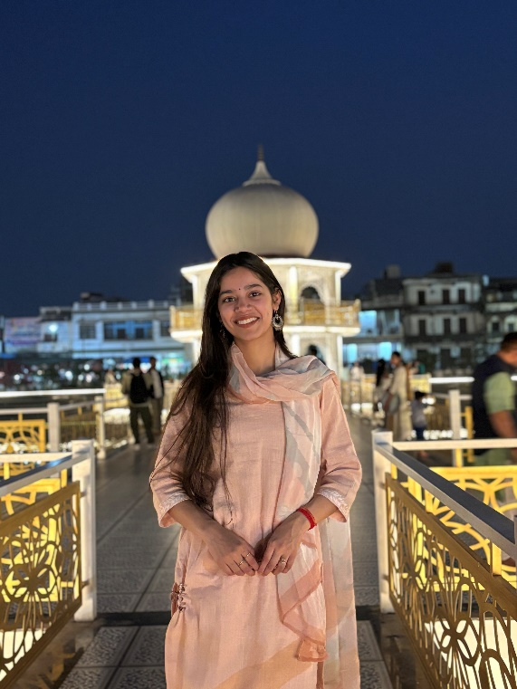

**Step 2: Remove the Background**

* Used **Remove.bg** to extract the person from the original background.
* Imported the extracted PNG file into **GIMP** for further manual refinements:
  + Cleaned up any leftover edges or artifacts using GIMP's **Free Select Tool** and **Eraser Tool**.
  + Applied mild feathering (approximately 1-2 pixels) to soften the edges and avoid any sharp cut-out effect.

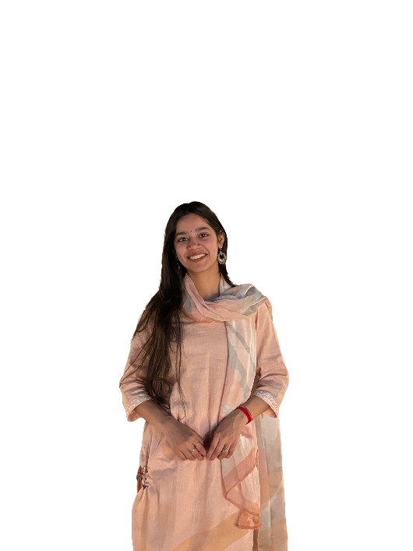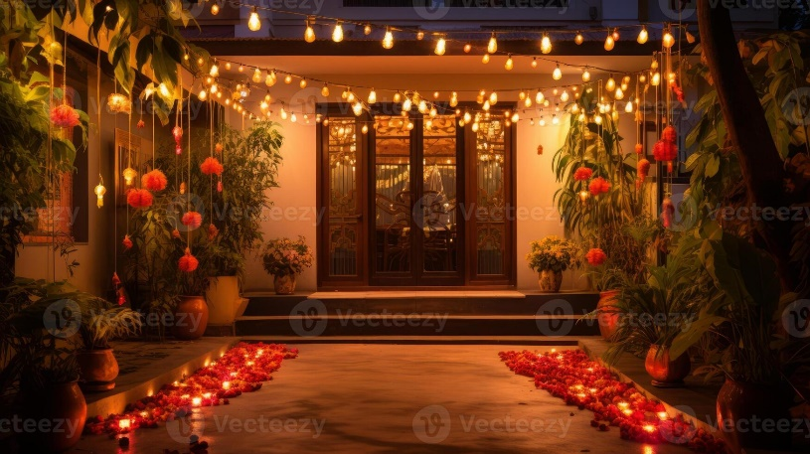

**Task 2: Analyzing Shadows and Lighting of the Background Image**

**Step 1: Detect and Classify Shadows**

*(Additional manual step: visual inspection and shadow mapping)*

* Closely examined the chosen background image to observe existing shadow types and directions.
* Identified:
  + **Hard Shadows** — clear, sharp-edged shadows.
  + **Soft Shadows** — diffuse, lighter shadows with smoother gradients.
* Manually determined which type of shadow was dominant based on the scene's lighting conditions (e.g. outdoor sunlight or indoor ambient light).

**Step 2: Generate Binary Masks (Reference Only)**

* Instead of automated shadow masks, visually mapped shadow regions to guide manual shadow creation during editing.

**Task 3: Determining Light Direction**

**Step 1: Compute Light Direction for Outdoor Scenes**

* Observed shadow lengths and angles of objects (like trees, poles, benches, etc.) in the background.
* Estimated light source direction (sun’s angle) by comparing object heights and corresponding shadow lengths.
* Used these observations to determine correct shadow placement for the inserted person.

**Step 2: Estimate Lighting for Indoor Scenes**

* For indoor scenarios, studied window placements, ceiling lights, and furniture shadows.
* Concluded that indoor lighting was mostly soft and multi-directional, which influenced both shadow softness and overall illumination applied to the person layer.

**Task 4: Coloring and Blending**

**Step 1: Additional Missing Steps for Realism**

**4.1: Perspective Matching**

* Used GIMP's **Scale Tool** to resize the person proportionally to match the scale of the scene.
* Applied the **Perspective Tool** to adjust any minor angle mismatches and ensure the person's posture and viewpoint fit the scene naturally.

**4.2: Color Matching**

* Sampled colors from surrounding elements of the background using GIMP's **Color Picker Tool**.
* Adjusted the inserted person layer manually via:
  + **Brightness-Contrast**
  + **Levels**
  + **Hue-Saturation**
* Applied minor adjustments in multiple passes to gradually match skin tones, clothing, and lighting warmth to the background.

**4.3: Shadow Creation**

* Duplicated the person layer.
* Converted the duplicate into a shadow by using **Colors → Colorize** and setting Lightness to zero (pure black).
* Applied GIMP’s **Perspective Tool** and **Shear Tool** to realistically position and flatten the shadow according to the light source direction.
* Blurred the shadow using **Gaussian Blur** to soften edges, especially for outdoor or indoor diffused lighting conditions.
* Reduced the shadow layer’s opacity to approximately 30%-50%, based on the shadow intensity present in the background.

**4.4: Ambient Occlusion (Contact Shadows)**

* Created a new transparent layer beneath the person.
* Used GIMP’s **Soft Brush Tool** at low opacity (around 15-20%) to manually paint subtle contact shadows beneath the feet and any surface contact areas.
* This added depth and prevented the floating appearance of the inserted person.

**4.5: Edge Blending**

* Applied slight feathering and soft manual erasing along the edges using a very soft brush.
* Carefully refined hairlines and edges of clothing to prevent hard transitions.

**4.6: Global Color Grading**

* Created a new layer filled with a solid warm color.
* Set its blending mode to **Soft Light** and reduced opacity (10%-15%) to apply a uniform color cast across the entire composition.
* This helped balance minor color differences between the person and the background, enhancing visual unity.

**Task 5: Generating the Final Output**

* Selected a park scene as the background.
* Inserted, resized, and positioned the person appropriately.
* Applied all adjustments described above: perspective correction, color matching, realistic shadow creation, edge blending, and global grading.
* Exported the completed composite as a high-resolution PNG image using GIMP’s **Export As** function.

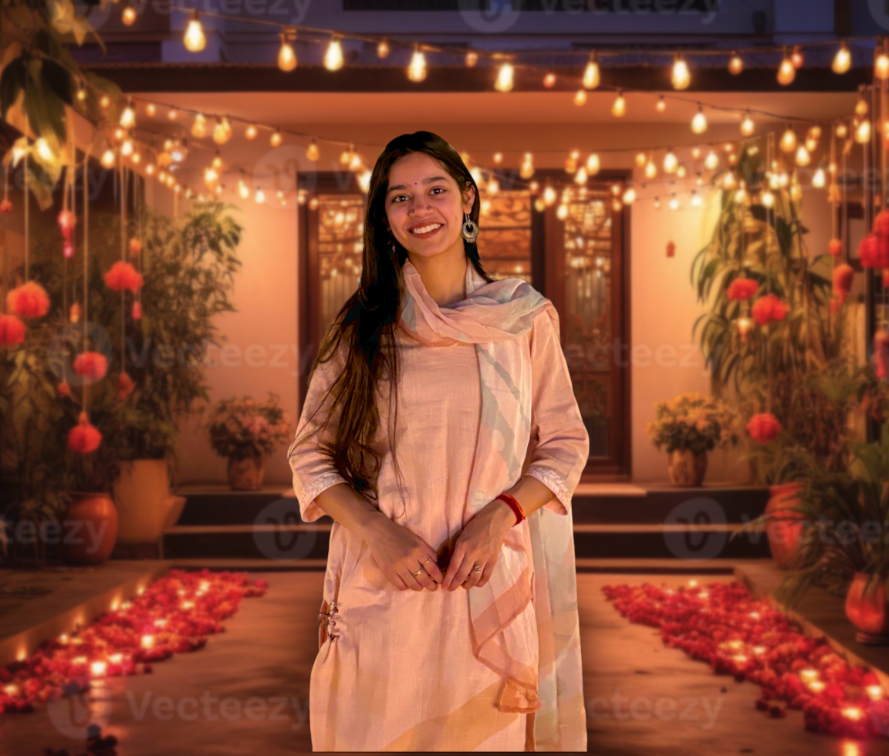

**Tools Used**

| **Task** | **Tool / Software** |
| --- | --- |
| Background Removal | Remove.bg |
| Image Editing | GIMP |
| Scaling / Positioning | GIMP Scale Tool, Perspective Tool |
| Shadow Creation | Duplicate Layers, Colorize, Perspective, Gaussian Blur |
| Color Matching | Brightness-Contrast, Levels, Hue-Saturation |
| Contact Shadows | Soft Brush Tool |
| Edge Blending | Feathering, Soft Eraser |
| Global Grading | Overlay Layer, Soft Light Mode |
| Export | GIMP Export As |

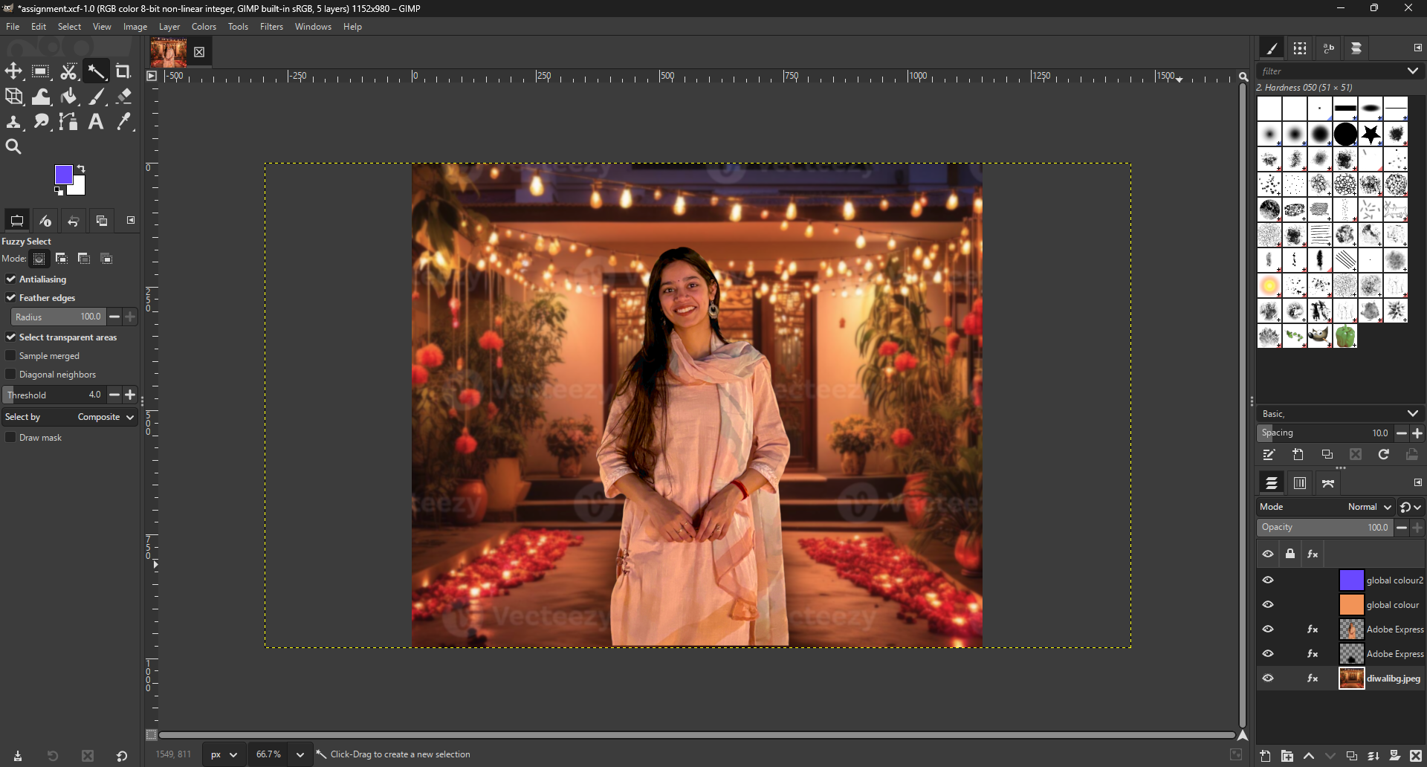

**Challenges Faced**

* Accurately estimating the background's light direction required careful visual analysis and comparison of multiple objects.
* Shadow creation involved repeated fine-tuning of opacity, blur strength, and placement to ensure natural appearance.
* Achieving consistent color tones demanded multiple small adjustments across several color correction tools.
* Edge refinement was a critical manual task to avoid an artificial “cutout” effect and blend the subject naturally into the scene.

**Conclusion**

By following a fully manual, step-by-step editing process in GIMP, I was able to integrate the person naturally into the background scene. Each stage — from background removal to final grading — was handled through careful observation and adjustment. The resulting image achieved seamless integration with accurate lighting, shadows, color balance, and perspective, producing a photorealistic final composition.